CHAPTER 6: Inside the atom
Worksheet 6.4

Putting nuclear energy
to use
Answers
Label the diagram and write down the steps in the process of electricity production.

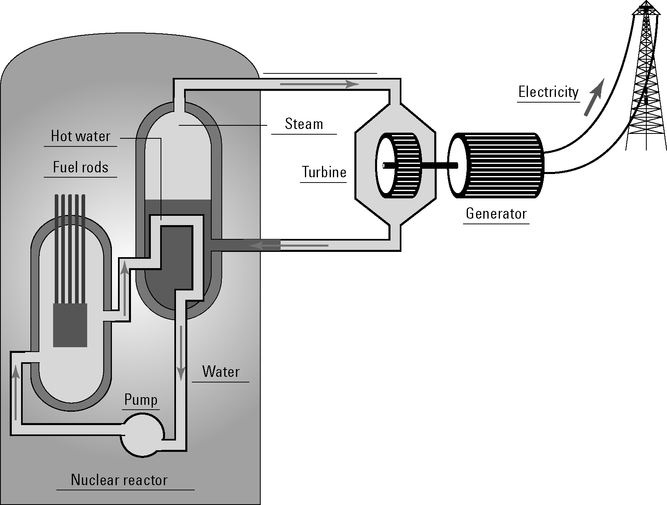

Steps
1. Inside the nuclear reactor, the uranium in the fuel rods undergoes fission and releases large amounts of heat energy.

2. The heat is absorbed by water circulating around the core and converts the water into steam.
3. The steam drives a turbine and the rotational energy generates electrical energy.
4. The electricity produced is fed into the electricity grid.
5. The water has lost its heat and is pumped back into the vessel around the core where the whole process is repeated.

